Chapter 16 Revision
Name: ____________________ Class: ____________________ Due date:
1. Which substance does not produce carbon dioxide when it burns in oxygen?（ ）
A butane B ethanol C ethene D hydrogen

2. The structure of an organic compound, X, is shown.
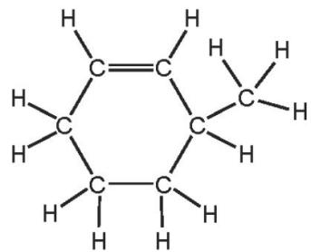
What is the molecular formula of X? （ ）
$C_{6}H_{9}$$C_{6}H_{12}$$C_{7}H_{12}$$C_{7}H_{14}$A. B. C. D.

5. Hydrocarbons obtained by fractional distillation of petroleum can be cracked to make useful products.
$M_{r}44?$Which substance could not be obtained by cracking propane, （ ）
$C_{2}H_{4}$$C_{3}H_{6}$$C_{4}H_{8}$A B C D H₂

4. Which statement about alkenes is not correct? （ ）
A The functional group is C=C
$−{CH}_{3}−$B The structural difference between one member and the next is
C They form a homologous series.
D They turn aqueous bromine from brown to colourless.

6. Which reaction is not a reaction which alkenes undergo? （ ）
A bromination B hydration C hydrogenation D hydrolysis
8. Which substances can be obtained by cracking hydrocarbons? （ ）
A ethanol and ethene
B ethanol and hydrogen
C ethene and hydrogen
D ethene and poly(ethene)

8. A hydrocarbon A is cracked to make B and hydrogen.
Compound C is formed by the addition polymerisation of B.
To which homologous series do A, B and C belong? （ ）
 | alkene | alkane
A | A | B and C
B | B | A and C
C | C | A and B
D | - | A and C

6. Alkenes are manufactured by cracking hydrocarbons obtained from petroleum.
Which row describes the size of the molecules in hydrocarbons P and Q and the effect of Q on aqueous bromine? （ ）
 | size of P molecules | size of Q molecules | effect of Q on aqueous bromine
A | large | small | decolourises
B | large | small | no effect
C | small | large | decolourises
D | small | large | no effect

4. Which hydrocarbon reacts with steam to produce ethanol? （ ）
$C_{2}H_{4}$$C_{2}H_{6}$$C_{3}H_{6}$$C_{2}H_{8}$A B C D

7 - (0620- W 2016- Paper 2 (Extended)/1- Q36) - ORGANIC CHEMISTRY
Butane reacts as shown.
$$butane\frac{catalyst}{andheat}butene+hydrogen$$
What is this type of reaction? （ ）
A combustion B cracking C polymerisation D reduction

3. The diagram shows some properties of two organic compounds X and Y.
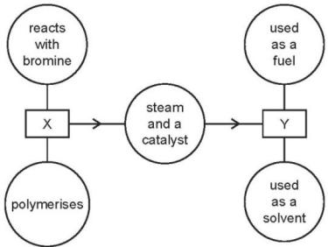
What are X and Y? （ ）
 | X | Y
A | ethane | ethanoic acid
B | ethane | ethanol
C | ethene | ethanoic acid
D | ethene | ethanol

7. The diagram shows a flow diagram.
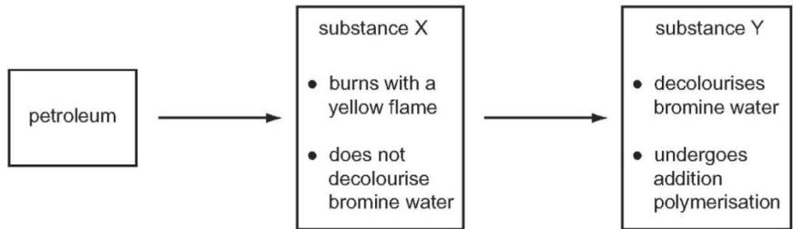
Which type of organic compounds are X and Y? （ ）
 | substance X | substance Y
A | alcohol | alkane
B | alkane | alkene
C | alkene | alkane
D | alkane | alcohol

8. In which reaction could one of the products belong to the same homologous series as the organic reactant? （ ）
A addition of steam to ethene
B combustion of an alkane
C cracking of an alkane
D polymerisation of ethene

1. Ethanol is an important chemical produced by the ….1. …. of ….2.…
Which words correctly complete gaps 1 and 2? （ ）
 | 1 | 2
A | combustion | ethane
B | combustion | glucose
C | fermentation | ethane
D | fermentation | glucose

6. Ethanol is produced from either ethene or sugar.
Which type of chemical reaction is used in each case? （ ）
 | ethene → ethanol | sugar → ethanol
A | addition | fermentation
B | addition | fractional distillation
C | distillation | fermentation
D | distillation | fractional distillation

8. Ethanol can be manufactured from substance X.
What is substance X? （ ）
A carbon dioxide B ethene C hydrogen D oxygen
12. Ethanol can be formed by
1 fermentation 2 reaction between steam and ethene
Which of these processes uses a catalyst? （ ）
 | 1 | 2
A | ✓ | ✓
B | ✓ | ×
C | × | ✓
D | × | ×
8. The diagram shows the structures of two organic molecules.
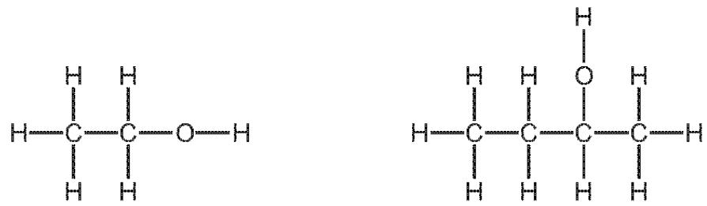
Which statement about these molecules is not correct? （ ）
A They are both alcohols.
B They both produce carbon dioxide and water when they burn in oxygen.
C They contain different functional groups.
D They have the same general formula.
5. Which process is not used during the production of ethanol? （ ）
A addition of steam to ethene
B fermentation
C fractional distillation
D reacting ethane with oxygen

10. Which type of reaction takes place when methane reacts with chlorine in the presence of ultraviolet light? （ ）
A addition B cracking C polymerisation D substitution

1. The structure of a compound is shown.
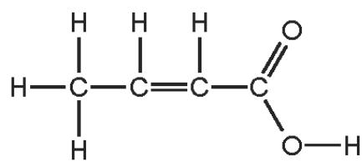
Which functional groups are present in this compound? （ ）
 | alcohol | alkene | carboxylic acid
A | ✓ | ✓ | ✓
B | ✓ | × | ×
C | × | ✓ | ✓
D | × | × | ✓

3. The table shows bonds that are present and bonds that are not present in compound X.
bond
C-C | ✓
C=C | ×
C-H | ✓
C-O | ✓
C=O | ✓
O-H | ✓
What type of compound is X? （ ）
A a carboxylic acid B an alcohol C an alkane D an alkene

7. Organic compounds may have names ending in - ane, - ene, - ol or - oic acid.
How many of these endings indicate the compounds contain double bonds in their molecules? （ ）
A 1 B 2 C 3 D 4

8. The list gives the names of four organic compounds.
ethane ethanoic acid ethanol ethene
Which bond do all four compounds contain? （ ）
$C=C$A C- C B C C- H D C- O

9. The structures of four organic compounds are shown.
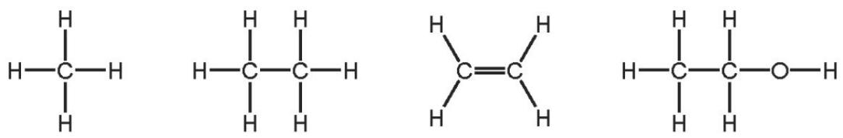
Which statement is not correct? （ ）
A Only one of the compounds is an alcohol.
B Only one of the compounds is an alkane.
C Only one of the compounds is unsaturated.
D Only three of the compounds are hydrocarbons.

1. The main constituent of natural gas is hydrocarbon X.
To which homologous series does X belong and how many atoms are in one molecule of X? （ ）
 | homologous series | number of atoms in one molecule
A | alkane | 1
B | alkane | 5
C | alkene | 1
D | alkene | 5

2. Ethanol is a fuel used in cars. It can be made from petroleum.
$$\begin{matrix}C_{4}H_{10}→C_{2}H_{4}+C_{2}H_{6} \\ C_{2}H_{4}+H_{2}O→C_{2}H_{5}OH \\ C_{2}H_{5}OH+3O_{2}→2{CO}_{2}+3H_{2}O\end{matrix}$$
Compounds of how many homologous series appear in these equations? （ ）
A 1 B 2 C 3 D 4

4. The diagram shows a reaction sequence.
Which row names the processes X, Y and Z? （ ）
 | X | Y | Z
A | cracking | fermentation | respiration
B | cracking | hydration | combustion
C | distillation | fermentation | respiration
D | distillation | hydration | combustion

5. During the process of cracking hydrocarbons, an ……. 1 ……. is converted into an ……. 2 …….
The presence of an ……. 3 ……. can be shown by a visible reaction with ……. 4 …….
Which words complete gaps 1, 2, 3 and 4? （ ）
 | 1 | 2 | 3 | 4
A | alkane | alkene | alkene | bromine
B | alkane | alkene | alkene | steam
C | alkene | alkane | alkane | bromine
D | alkene | alkane | alkane | steam

2. Hydrocarbons are compounds which contain hydrogen and carbon only.
$10{cm}^{3}$$C_{x}H_{y}$$100{cm}^{3}$$25{cm}^{3}$$50{cm}^{3}$ of a gaseous hydrocarbon, , are burned in of oxygen, which is an excess of oxygen.- After cooling to room temperature and pressure, there is of unreacted oxygen, of carbon dioxide and some liquid water.
All volumes are measured under the same conditions of temperature and pressure.
What is meant by an excess of oxygen
.......................................................................................................................................
...................................................................................................................................?
What was the volume of oxygen that reacted with the hydrocarbon
.......................................................................................................................................
.....................................................................................................................................?
Complete the table below to express the smallest whole number ratio of volume of volume of volume of carbon dioxide hydrocarbon reacted oxygen reacted produced
 | volume of hydrocarbon reacted | volume of oxygen reacted | volume of carbon dioxide produced
smallest whole number ratio of volumes
Use your answer to (a)(ii) to find the mole ratio in the equation below.
Complete the equation and deduce the formula of the hydrocarbon.
$$……………………………………………………………………………………………………………………………………………………………………………………$$
formula of hydrocarbon =..............................................................................

$C_{2}H_{6}$11. Ethane, , is a member of the homologous series called alkanes.
$C_{2}H_{6}OH$Ethanol, , is a member of the homologous series called alcohols.
Alkanes are hydrocarbons. What is meant by the term hydrocarbon?
..............................................................................................................................
..............................................................................................................................[2]
ii.All members of a homologous series can be represented by a general formula. State the general formula of:
alkanes ...........................................................................................................................alcohols .....................................................................................................................[2]
State two characteristics, other than having the same general formula, of members of a homologous series.
1 ..............................................................................................................................
2 ..............................................................................................................................[2]
Ethane can react with chlorine in a substitution reaction.
State one essential reaction condition.
.............................................................................................................................[1]
ii.Draw the structure of the organic product formed by substitution of one of the hydrogen atoms in ethane with chlorine. Show all of the atoms and all of the bonds.

iii.Name the product of the substitution reaction between ethane and chlorine that does not contain carbon.
..............................................................................................................................[1]
c.Propan⁻¹-ol is an alcohol.
The structure of propan- 1- ol is shown.
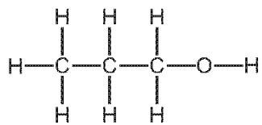
Propan- 1- ol reacts with ethanoic acid to form an ester.
Give the name of the ester formed in this reaction.
..............................................................................................................................[1]
d.Ester Y has the structure shown.
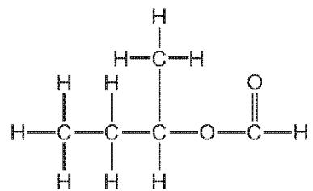
ester Y
Give the molecular formula of ester Y.
..............................................................................................................................
Draw the structures of the carboxylic acid and the alcohol used to make ester Y.
Show all of the atoms and all of the bonds.

Give the name of the carboxylic acid and the alcohol.
..............................................................................................................................
structure of the carboxylic acid name of the carboxylic acid structure of the alcohol name of the alcohol
Nylon is a polyamide.
Complete the diagram to show the structure of nylon. Show all of the atoms and all of the bonds present in the linkages.

12. The structures of five organic compounds, A, B, C, D and E, are shown. Answer the questions that follow. Each letter may be used once, more than once or not at all.
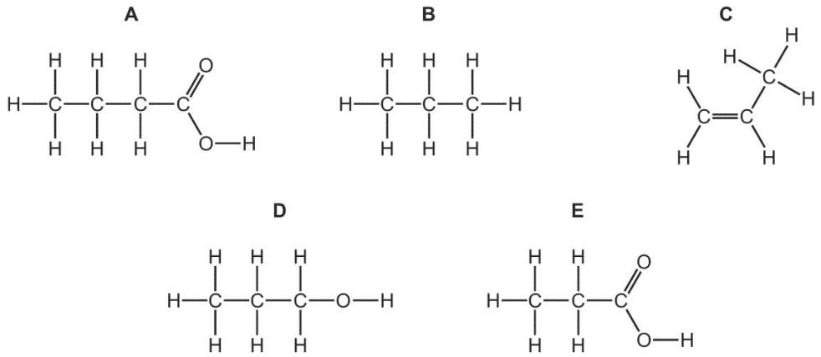
Give the letter of the compound that is propan⁻¹-ol............
${CH}_{2}$Give the letter of the compound that has the empirical formula ...........
Give the letter of one compound that reacts with bromine in an addition reaction............
Give the letter of one compound that reacts with chlorine to form the compound shown.
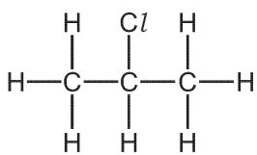
Give the letters of two compounds that can react with each other to form an ester.
......................[1]
Give the letter of the compound that is in the same homologous series as hex- 1- ene.
......................[1]
Give the letter of one compound that is an acid.......................[1]
Draw a structural isomer of compound D.
Show all of the atoms and all of the bonds.

[1]
$•$25. Use x to represent an electron from a carbon atom. Use o to represent an electron from a hydrogen atom. Use to represent an electron from an oxygen atom.
Methanol is manufactured using the following method.
$$\begin{aligned}&{CH}_{4}(g)+H_{2}O(g)→CO(g)+3H_{2}(g) \\ &CO(g)+2H_{2}(g)⇌{CH}_{3}OH(g)\end{aligned}$$
The conditions for reaction 2 are:..........................................................
${250}^{∘}C$pressure 100 atmospheres catalyst a mixture of copper, zinc oxide and aluminium oxide temperature
The forward reaction is exothermic.
Why is high pressure used in reaction 2?
...........................................................................................................................................................................................................................................................................[2]
${250}^{∘}C$${350}^{∘}C$ii.Explain why using a catalyst at is preferred to using a higher temperature of and no catalyst.
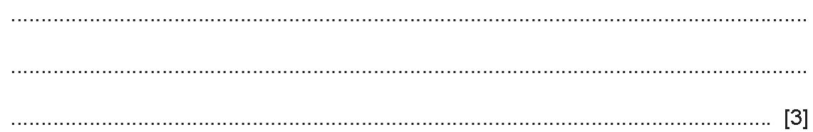
c.Methanol is oxidised by atmospheric oxygen. This reaction is catalysed by platinum.
...............................................................................................................................................................................................................................................................................
d.The products of this reaction include a carboxylic acid.
Give its name and structural formula.
name..............................................................................................................................
structural formula showing all bonds

[2]
ii.Deduce the name of the ester formed by the reaction of methanol with the carboxylic acid named in (i).
.............................................................................................................................................................................................................................................................................................................................................................................................................[1]
14. The alcohols form a homologous series.
Give three characteristics which all members of a homologous series share.
a........................................................................................................................
b........................................................................................................................
c........................................................................................................................
ii.Give the name of the third member of this series.
name..........................................................................................................................
$M_{r}=158$Iii.Deduce the molecular formula of the alcohol whose . Show your working.

Iv.Explain why the following two alcohols are isomers.
.......................................................................................................................................
.......................................................................................................................................
.......................................................................................................................................
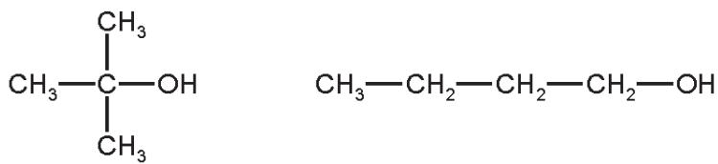
[2]
c.This question is based on typical reactions of butan⁻¹-ol.
${CH}_{3}{−CH}_{2}{−CH}_{2}{−CH}_{2}−OH$d.When butan⁻¹-ol, , is passed over the catalyst silicon(IV) oxide, water is lost.
Deduce the name and the structural formula of the organic product in this reaction.
Name.............................................................................................................................
structural formula

ii.Suggest the name of the ester formed from butanol and ethanoic acid.
...................................................................................................................................[1]
Butan- 1- ol is oxidised by acidified potassium manganate(VII).
Deduce the name and the structural formula of the organic product in this reaction.
Name...........................................................................................................................
structural formula.

15. Alcohols can be made by fermentation or from petroleum.
Ethanol can be made by the fermentation of glucose.
$$\begin{matrix}C_{6}H_{12}O_{6}(aq)\overset{yeast}{→}2C_{2}H_{5}OH(aq)+2{CO}_{2}(g)exothermicreaction\end{matrix}$$
Yeast are living single- cell fungi which ferment glucose by anaerobic respiration.
This reaction is catalysed by enzymes from the yeast.
What is meant by the term respiration?
.......................................................................................................................................
...................................................................................................................................[3]
Anaerobic means in the absence of oxygen.
Name the products formed from respiration in the presence of oxygen.
...................................................................................................................................[1]
What are enzymes?
......................................................................................................................................
...................................................................................................................................[1]
Suggest a method of measuring the rate of this reaction.
...................................................................................................................................[1]

19. Ethanol is manufactured by two different processes.
For each process, name the organic reactant and state the type of reaction.
organic reactant ...............................................................................................
type of reaction organic reactant type of reaction ........................................[4]
Alcohols can be oxidised to form carboxylic acids.
Name a suitable oxidising agent for this reaction.
Alcohols can be partially oxidised to form aldehydes.......................................
Aldehydes are a homologous series of organic compounds.......................................
Partial oxidation is achieved by reacting an alcohol with the oxidising agent in distillation apparatus as shown.
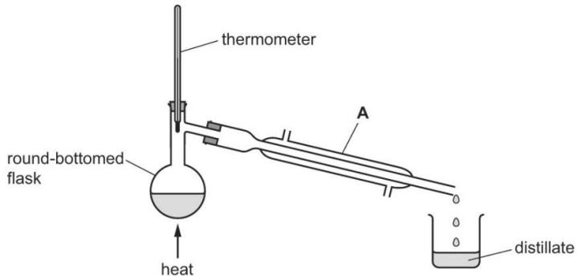
Name apparatus A.......................................[1]
ii.On the diagram, use one arrow to show where water enters apparatus A.
iii.The table shows some information about aldehydes.
iv.Complete the table.
name | ………….. | ethanal | propanal | butanal
molecular formula | CH₄O | C₂H₄O | C₃H₆O | …………..
ii.Deduce the general formula of aldehydes.......................................[1]

The structural formula of ethanal is shown.
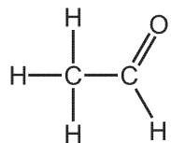
$C=O$The group in aldehydes is at the end of the carbon chain.
This is a reactive part of the molecule.
What is the name given to the reactive part of any organic molecule?
............................................................................[1]
ii.Complete the dot- and- cross diagram to show the electron arrangement of a molecule of ethanal. Inner shells have been drawn.
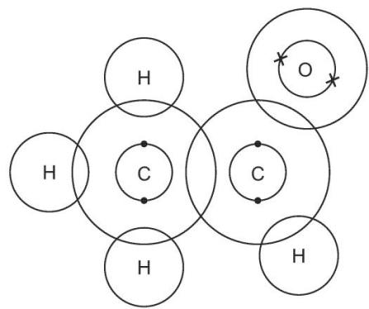
$C=O$$C=O$$C_{3}H_{6}O$Propanone belongs to a homologous series called ketones. Ketones have the same group as aldehydes but the group is not at the end of the carbon chain. Propanone has the same molecular formula as propanal, .
What term is used to describe molecules with different structures but with the same molecular formula............................................................................?
$C_{3}H_{6}O$ii.Suggest the structure of propanone, . Show all of the atoms and all of the bonds.
17. Ethanol can be produced by fermentation or by the catalytic addition of steam to ethene.
Which row shows an advantage and a disadvantage for each process? （ ）
 | fermentation |  | catalytic addition of steam to ethene
 | advantage | disadvantage | advantage | disadvantage
A | batch process | slow reaction | continuous process | fast reaction
B | fast reaction | continuous process | pure ethanol formed | renewable raw material
C | renewable raw material | batch process | pure ethanol formed | slow reaction
D | renewable raw material | impure ethanol formed | fast reaction | finite raw material

19. Two processes used for the large- scale production of ethanol are shown.
process 1 A compound containing carbon, hydrogen and oxygen is used to produce ethanol.
process 2 A compound containing carbon and hydrogen only is used to produce ethanol.
Which statement is correct? （ ）
A Process 1 uses a renewable starting material.
B Process 1 is done at a very high temperature.
C Process 2 involves fermentation.
D Process 2 is done at room temperature.

15. Ethanol is manufactured by fermentation or by the catalytic addition of steam to ethene.
Which statement is correct? （ ）
A Fermentation uses a higher temperature than the catalytic addition of steam to ethene.
B Fermentation uses a non- renewable resource.
C The catalytic addition of steam to ethene produces purer ethanol than fermentation.
D The catalytic addition of steam to ethene uses a biological catalyst.

13 . The alcohols form a homologous series. The first five members are given in the table below.
alcohol | formula | heat of combustion in kJ/mol
methanol | CH₃OH | 730
ethanol | CH3-CH2-OH | 1380
propan⁻¹-ol
butan⁻¹-ol | CH3-CH2-CH2-CH2-OH | 2680
pentan⁻¹-ol | CH3-CH2-CH2-CH2-CH2-OH | 3350
Complete the table. [2]
Complete the equation for the combustion of pentan- 1- ol in excess oxygen.
$$C_{5}H_{11}OH+……O_{2}→…………………………………………………………………………………………$$
State three characteristics of a homologous series other than the variation of physical properties down the series.
..................................................................................................................................
..................................................................................................................................
..................................................................................................................................
c.The following alcohols are isomers.
$${CH}_{3}{−CH}_{2}{−CH}_{2}{−CH}_{2}−OHand({CH}_{3})_{2}CH{−CH}_{2}−OH$$
Explain why they are isomers.
..................................................................................................................................
..................................................................................................................................
..................................................................................................................................

ii.Describe how ethanol is made from petroleum.
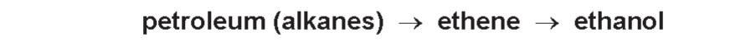
..................................................................................................................................
..................................................................................................................................
..................................................................................................................................[4]

16. Ethanol is manufactured by fermentation or by the catalytic addition of steam to ethene.
What is an advantage of ethanol manufacture by fermentation instead of by the catalytic addition of steam to ethene? （ ）
A Ethanol manufactured by fermentation is purified by distillation.
B Ethanol manufacture by fermentation produces purer ethanol.
C Ethanol manufacture by fermentation uses large areas of land.
D Ethanol manufacture by fermentation uses renewable resources.

14. Ethanol is manufactured by the catalytic addition of steam to ethene and by fermentation.
Which row shows an advantage and a disadvantage of using the catalytic addition of steam to ethene compared to fermentation? （ ）
 | advantage | disadvantage
A | fast | the product is impure
B | fast | uses non-renewable materials
C | the product is pure | slow
D | uses renewable materials | slow

$100cm^{3}$iv.A piece of magnesium was added to of an aqueous acid. The time taken for the metal to react completely was measured. This experiment was repeated using different aqueous acids. The same volume of acid was used in each experiment and the pieces of magnesium used were identical. In one experiment the reaction was carried out at a different temperature.
experiment | acid | concentration in mol/dm³ | temperature /℃ | time /minutes
A | propanoic | 1.0 | 20 | 5
B | propanoic | 1.0 | 30 | 3
C | propanoic | 0.5 | 20 | 8
D | hydrochloric | 1.0 | 20 | 1
Explain the following in terms of collision rate between reacting particles.
...............................................................................................................................................................................................................................................................................
.......................................................................................................................................
Why is the rate in experiment C slower than the rate in experiment A?
.......................................................................................................................................
.......................................................................................................................................
Why is the rate in experiment B faster than the rate in experiment A?
.......................................................................................................................................
.......................................................................................................................................
Why is the rate in experiment D faster than the rate in experiment A?
.......................................................................................................................................
.......................................................................................................................................

12. What are the properties of a dilute solution of ethanoic acid? （ ）
 | smell | appearance
A | odourless | colourless
B | odourless | red
C | pungent smell | colourless
D | pungent smell | red

15. What are the properties of aqueous ethanoic acid? （ ）
 | decolourises bromine water | reacts with calcium carbonate to make carbon dioxide | turns damp red litmus blue
A | ✓ | ✓ | x
B | ✓ | x | ✓
C | x | ✓ | x
D | x | x | ✓
9. Some properties of an organic compound J are listed.
It is a liquid at room temperature. It is soluble in water. A solution of J reacts with calcium carbonate to form carbon dioxide. A solution of J has a pH of 3.
In which homologous series does J belong? （ ）
A alkane B alkene C alcohol D carboxylic acid

11. Which statements about aqueous ethanoic acid are correct? （ ）
1 Ethanoic acid contains the functional group - COOH.
2 Ethanoic acid reacts with carbonates to produce hydrogen.
3 Ethanoic acid turns Universal Indicator paper blue.
4 Ethanoic acid has a pH lower than pH 7.
A 1 and 2 B 1 and 3 C 1 and 4 D 2 and 4
10. The structure of a compound, Y, is shown.
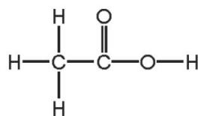
Which row describes some of the physical properties of Y? （ ）
 | colourless | characteristic smell | dissolves in water
A | no | no | no
B | no | no | yes
C | yes | yes | no
D | yes | yes | yes

12. Propenoic acid is an unsaturated carboxylic acid. The structural formula of propenoic acid is given below.
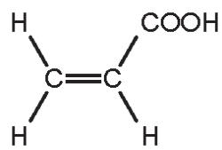
Describe how you could show that propenoic acid is an unsaturated compound.
test .................................................................................................................................................................................................................................................................................................................................................................................................................
result ....................................................................................................[2]

ii.Without using an indicator, describe how you could show that a compound is acid.
test................................................................................................................................................................................................................................................................................................................................................................................................................
result....................................................................................................[2]

Propenoic acid reacts with ethanol to form an ester.
Deduce the name of this ester. Draw its structural formula.
name of ester..................................................
structural formula showing all bonds

$C_{6}H_{8}O_{4}$c.An organic compound has a molecular formula .
It is an unsaturated carboxylic acid.
One mole of the compound reacts with two moles of sodium hydroxide.
i.Explain the phrase molecular formula.
ii.One mole of this carboxylic acid reacts with two moles of sodium hydroxide.
How many moles of - COOH groups are there in one mole of this compound?
...............................................................................................................................................................................................................................................................................

iii.What is the formula of another functional group in this compound?
.......................................................................................................................................
iv.Deduce a structural formula of this compound

17. Butane is oxidised to a mixture of carboxylic acids by oxygen in the presence of a catalyst. The acids formed are methanoic acid, ethanoic acid and propanoic acid - the first three members of the carboxylic acid homologous series.
Give the name and structural formula of the fourth member of this series.
name.....................................................................................................................
structural formula showing all the atoms and bonds

ii.State three characteristics of a homologous series.
...................................................................................................................................................................................................................................................................................................................................................................................................................[3]
All members of this series are weak acids.
What is meant by the term weak acid?
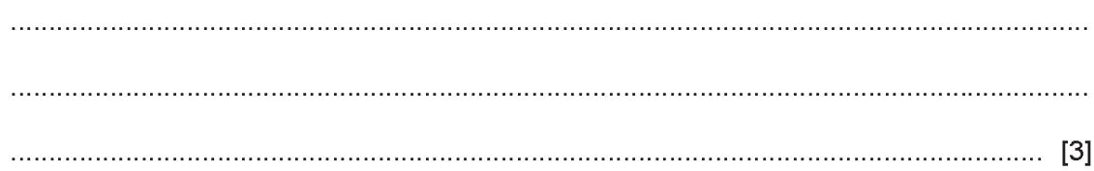
${CH}_{3}{COOCH}_{2}{CH}_{3}$Carboxylic acids react with alcohols to form esters. Ethanol reacts with ethanoic acid to form the ester ethyl ethanoate,
Give the name and formula of the ester which is formed from methanol and propanoic acid.
name..................................................................................................................
formula.....................................................................................................................
${CH}_{3}{COOCH}_{3}$ii.What is the name of the ester which has the formula ?
................................................................................................................................[1]
c.Complete the equation for the oxidation of butane to propanoic acid.
$$3C_{4}H_{10}+……O_{2}→4C_{2}H_{5}COOH+……H_{2}O$$
ii.Name another compound which can be oxidised to propanoic acid.
...................................................................................................................................[1]
4 .Two hydrocarbons have the structures shown.
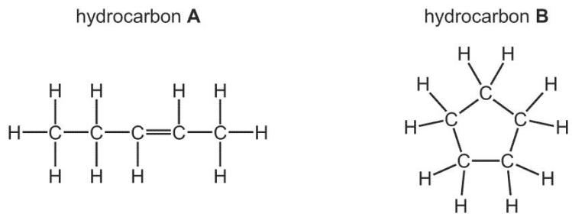
Why are these two compounds hydrocarbons?
...........................................................................................................................
Hydrocarbon B reacts in the same way as a typical alkane.
Describe a chemical test to tell the difference between hydrocarbon A and hydrocarbon B.
...........................................................................................................................
...........................................................................................................................
State the name of the reagent you would use and the result you would obtain with hydrocarbon A and hydrocarbon B.
reagent...........................................................................................................................
result with hydrocarbon A...............................................................................................
result with hydrocarbon B...............................................................................................
Alkenes react with steam to form alcohols.
Compound C is an alcohol.
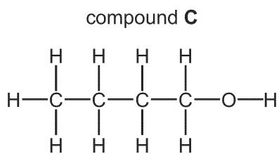
Draw the structure of the alkene which could be reacted with steam to make compound C. Show all of the atoms and all of the bonds.
c.Alkenes can form polymers.
d.What type of polymerisation occurs when alkenes form polymers
...........................................................................................................................?
c.Ethene will react with steam to form ethanol. Propene will react with steam to form two isomers, both of which are alcohols. Suggest the structures of these alcohols.
.......................................................................................................................................
.......................................................................................................................................
.......................................................................................................................................
d.Esters are organic chemicals noted for their characteristic smells.
Ethanoic acid and methanol will react to form an ester.
e.Name the catalyst needed to form an ester from ethanoic acid and methanol.
.................................................................................................................................. [1]
ii.Name the ester formed when ethanoic acid reacts with methanol.
..................................................................................................................................[1]
iii.Draw the structure of the ester formed when ethanoic acid reacts with methanol. Show all bonds.

[2]
Give the name of a polyester.
...................................................................................................................................[1]

6. There are three functional groups in compound A.
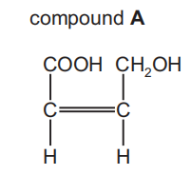
Compound A can be used as a single monomer to produce two different polymers.
1)Draw one repeat unit of the addition polymer formed from compound A.

2)What type of condensation polymer is formed from compound A?
.........................................................................................................................[1]
3)Molecules A and B can form condensation polymers.
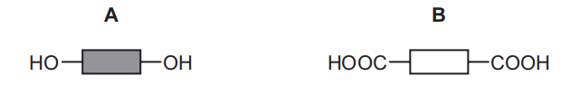
(a) Each molecule has two identical functional groups.
(i) Name the functional group in B.
.........................................................................................................................[1]
(ii)Draw the part of the structure of the synthetic polymer that would form when two molecules of A and two molecules of B combine. Show all of the bonds in the linkages.

[3]
(iii)Name the other product formed when molecules of A and B undergo polymerisation.
.........................................................................................................................[1]
(b) Molecule A is a simple sugar unit which can be made by hydrolysis of complex carbohydrates.
Draw part of the complex carbohydrate that could be hydrolysed to make molecules of A.Include one linkage and show all of the bonds in the linkage.

[1]

